# CS 340 README

## About the Project/Project Title

The Animal Shelter Dashboard Project is designed to create an interactive web dashboard for managing and visualizing animal rescue data. The dashboard allows users to filter and display data based on rescue types, preferred breeds, and other criteria using Python and Dash framework.

## Motivation

The motivation behind this project is to provide Grazioso Salvare with a comprehensive tool for visualizing and managing animal rescue data from the Austin Animal Center (AAC). By leveraging MongoDB and Dash, developers can easily interact with and visualize complex data sets without extensive frontend development.

## Getting Started

### **Setup Instructions**

1. **Set up the MongoDB Database:**
   * Ensure MongoDB is installed and running on your system.
   * Create a database named "AAC" and a collection named "animals".
2. **Import the AAC Dataset:**
   * Use the mongoimport tool to import the AAC Outcomes dataset into MongoDB.
   * Ensure the database name is set to "AAC" and the collection name to "animals".
3. **Set Up User Authentication:**
   * Create a user account for the "AAC" database in MongoDB to ensure secure access.
4. **Install Required Python Libraries:**
   * Python 3.x
   * MongoDB (PyMongo driver)
   * Dash
   * JupyterDash
   * Plotly
   * Dash Leaflet

### **Development Environment**

* **Python Libraries Used:**
  + dash and dash-html-components for creating the dashboard layout.
  + dash-core-components for interactive components like dropdowns and radio items.
  + dash-table for displaying data tables with filtering and sorting capabilities.
  + dash-leaflet for integrating interactive maps.
  + plotly and matplotlib for creating data visualizations like pie charts.
* **Rationale for Tools Used:**
  + **MongoDB:** Chosen for its flexibility with unstructured data and scalability. Ideal for storing and querying diverse animal rescue records efficiently.
  + **Dash Framework:** Provides a Python framework for building analytical web applications. Allows easy integration of complex data visualizations and interactive components.

## Installation

To run the Animal Shelter Dashboard project, ensure you have Python installed along with the necessary libraries listed above. Clone the repository to your local machine and follow the setup instructions provided.

## Usage

The Animal Shelter Dashboard allows users to:

* Filter data based on rescue types (Water, Mountain or Wilderness, Disaster or Individual Tracking).
* Select preferred breeds and sex of animals for filtering.
* View filtered data in a sortable and searchable data table.
* Visualize data using interactive maps and pie charts.

### Code Example

Below is an example demonstrating the basic functionality of the Animal Shelter Dashboard:

# Example usage of the AnimalShelter class

from animal_shelter import AnimalShelter

# Instantiate the AnimalShelter class

shelter = AnimalShelter()

# Fetch all data from MongoDB and load it into a DataFrame

all_data = shelter.read({})

# Perform filtering based on rescue type and sex

filtered_data = shelter.filter_data('Water', 'Female')

# Display filtered results in a data table or visualization

print(filtered_data)

## **Challenges Faced**

* **Integration of Dash Components:** Initially faced challenges integrating Dash components like interactive maps and charts due to version compatibility issues.
* **Data Filtering Logic:** Ensuring accurate data filtering based on multiple criteria required iterative refinement of MongoDB queries and Dash callback functions.

## **Conclusion**

The Animal Shelter Dashboard project provides an efficient solution for visualizing and managing animal rescue data using MongoDB and Dash. It simplifies the process of filtering, visualizing, and interacting with complex datasets, making it a valuable tool for animal shelter management and analysis.

<https://youtu.be/d-pUq5S4eDc>

[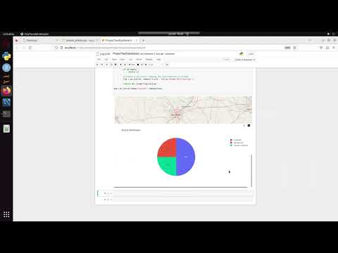](https://youtu.be/d-pUq5S4eDc)

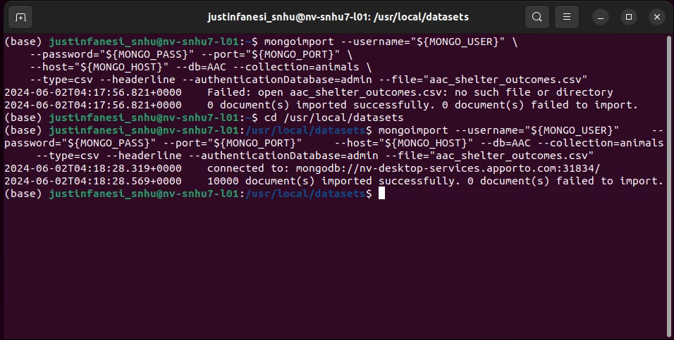

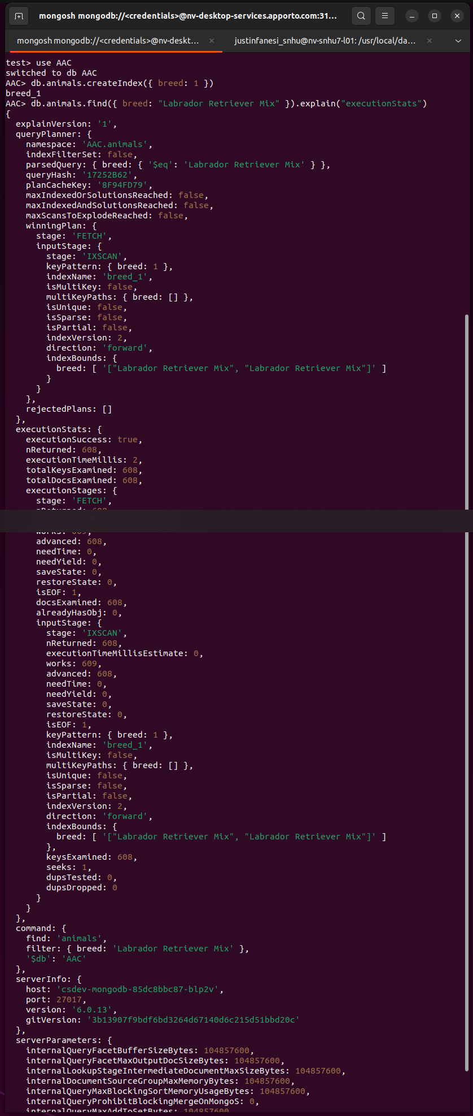

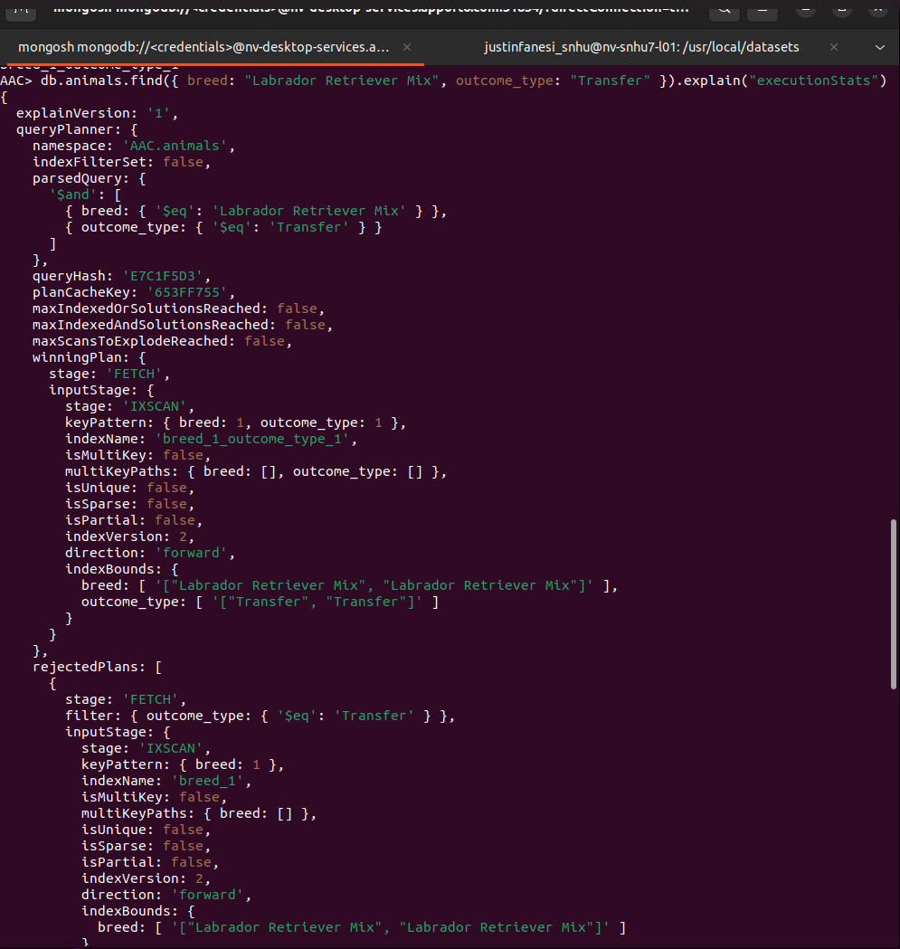

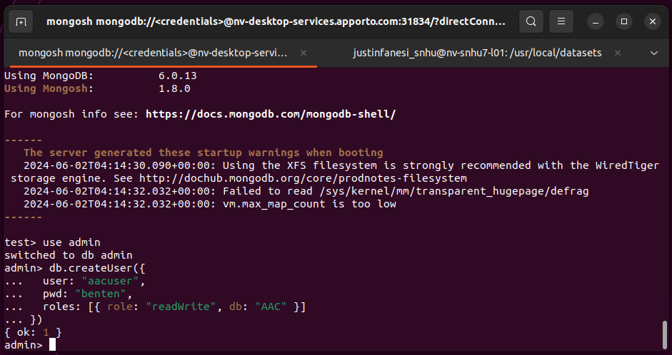

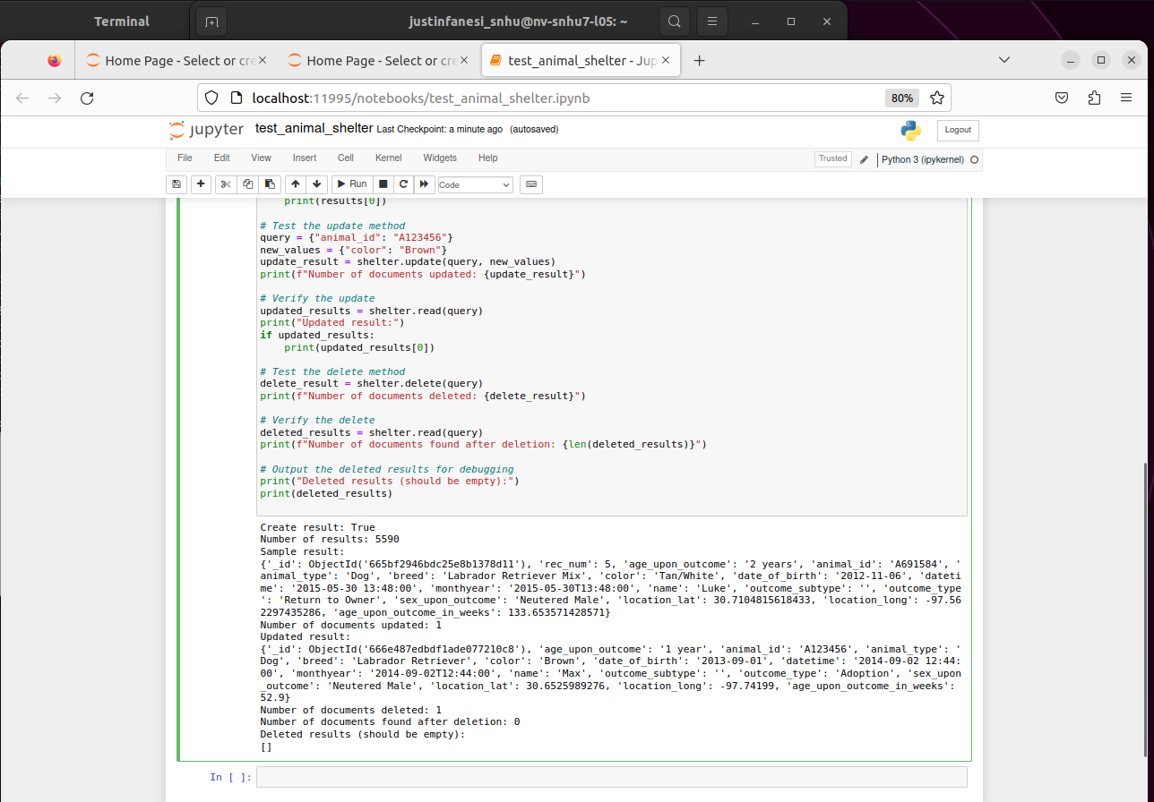

## Contact

Justin Fanesi